|  |
| --- |
| , RD Dep. |
| **Report Introduction to OLAP** |

|  |  |  |  |  |  |
| --- | --- | --- | --- | --- | --- |
| REVISION HISTORY | | | | | |
| Ver. | Description of Change | Author | Date | Approved | |
| Name | Effective Date |
| 1.0 | Initial Version | Hanna Hul | 15-Nov-2017 |  |  |
|  |  |  |  |  |  |

Contents

1. SQL for analysis 3

# SQL for analysis

1. Topic 2. Task 2 (please, make an example of usage GROUPING_ID).

create synonym channels for sh.channels;

create synonym times for sh.times;

create synonym countries for sh.countries;

create synonym customers for sh.customers;

create synonym sales for sh.sales;

select DECODE(grouping_id(times.calendar_month_desc),1,'GRAND TOTAL',times.calendar_month_desc) year_month,

-- grouping_id(times.calendar_month_desc) id_,

DECODE(grouping_id(times.calendar_month_desc,channels.channel_desc,

countries.country_name),3,'Total by Channels',channels.channel_desc) channel,

DECODE(grouping_id(times.calendar_month_desc,channels.channel_desc,

countries.country_name),1,concat(channels.channel_desc, ' Total by States'),countries.country_name) country,

round(max (amount_sold)) max_sales$,

round(min (amount_sold)) min_sales$,

round(sum(amount_sold)) sales$

from sales, times, channels, customers, countries

where sales.time_id = times.time_id and

sales.channel_id = channels.channel_id and

sales.cust_id = customers.cust_id and

customers.country_id = countries.country_id and

times.calendar_month_desc = '2000-12' and

channels.channel_desc IN ('Internet','Direct Sales')

group by rollup (times.calendar_month_desc,

channels.channel_desc,

countries.country_name);

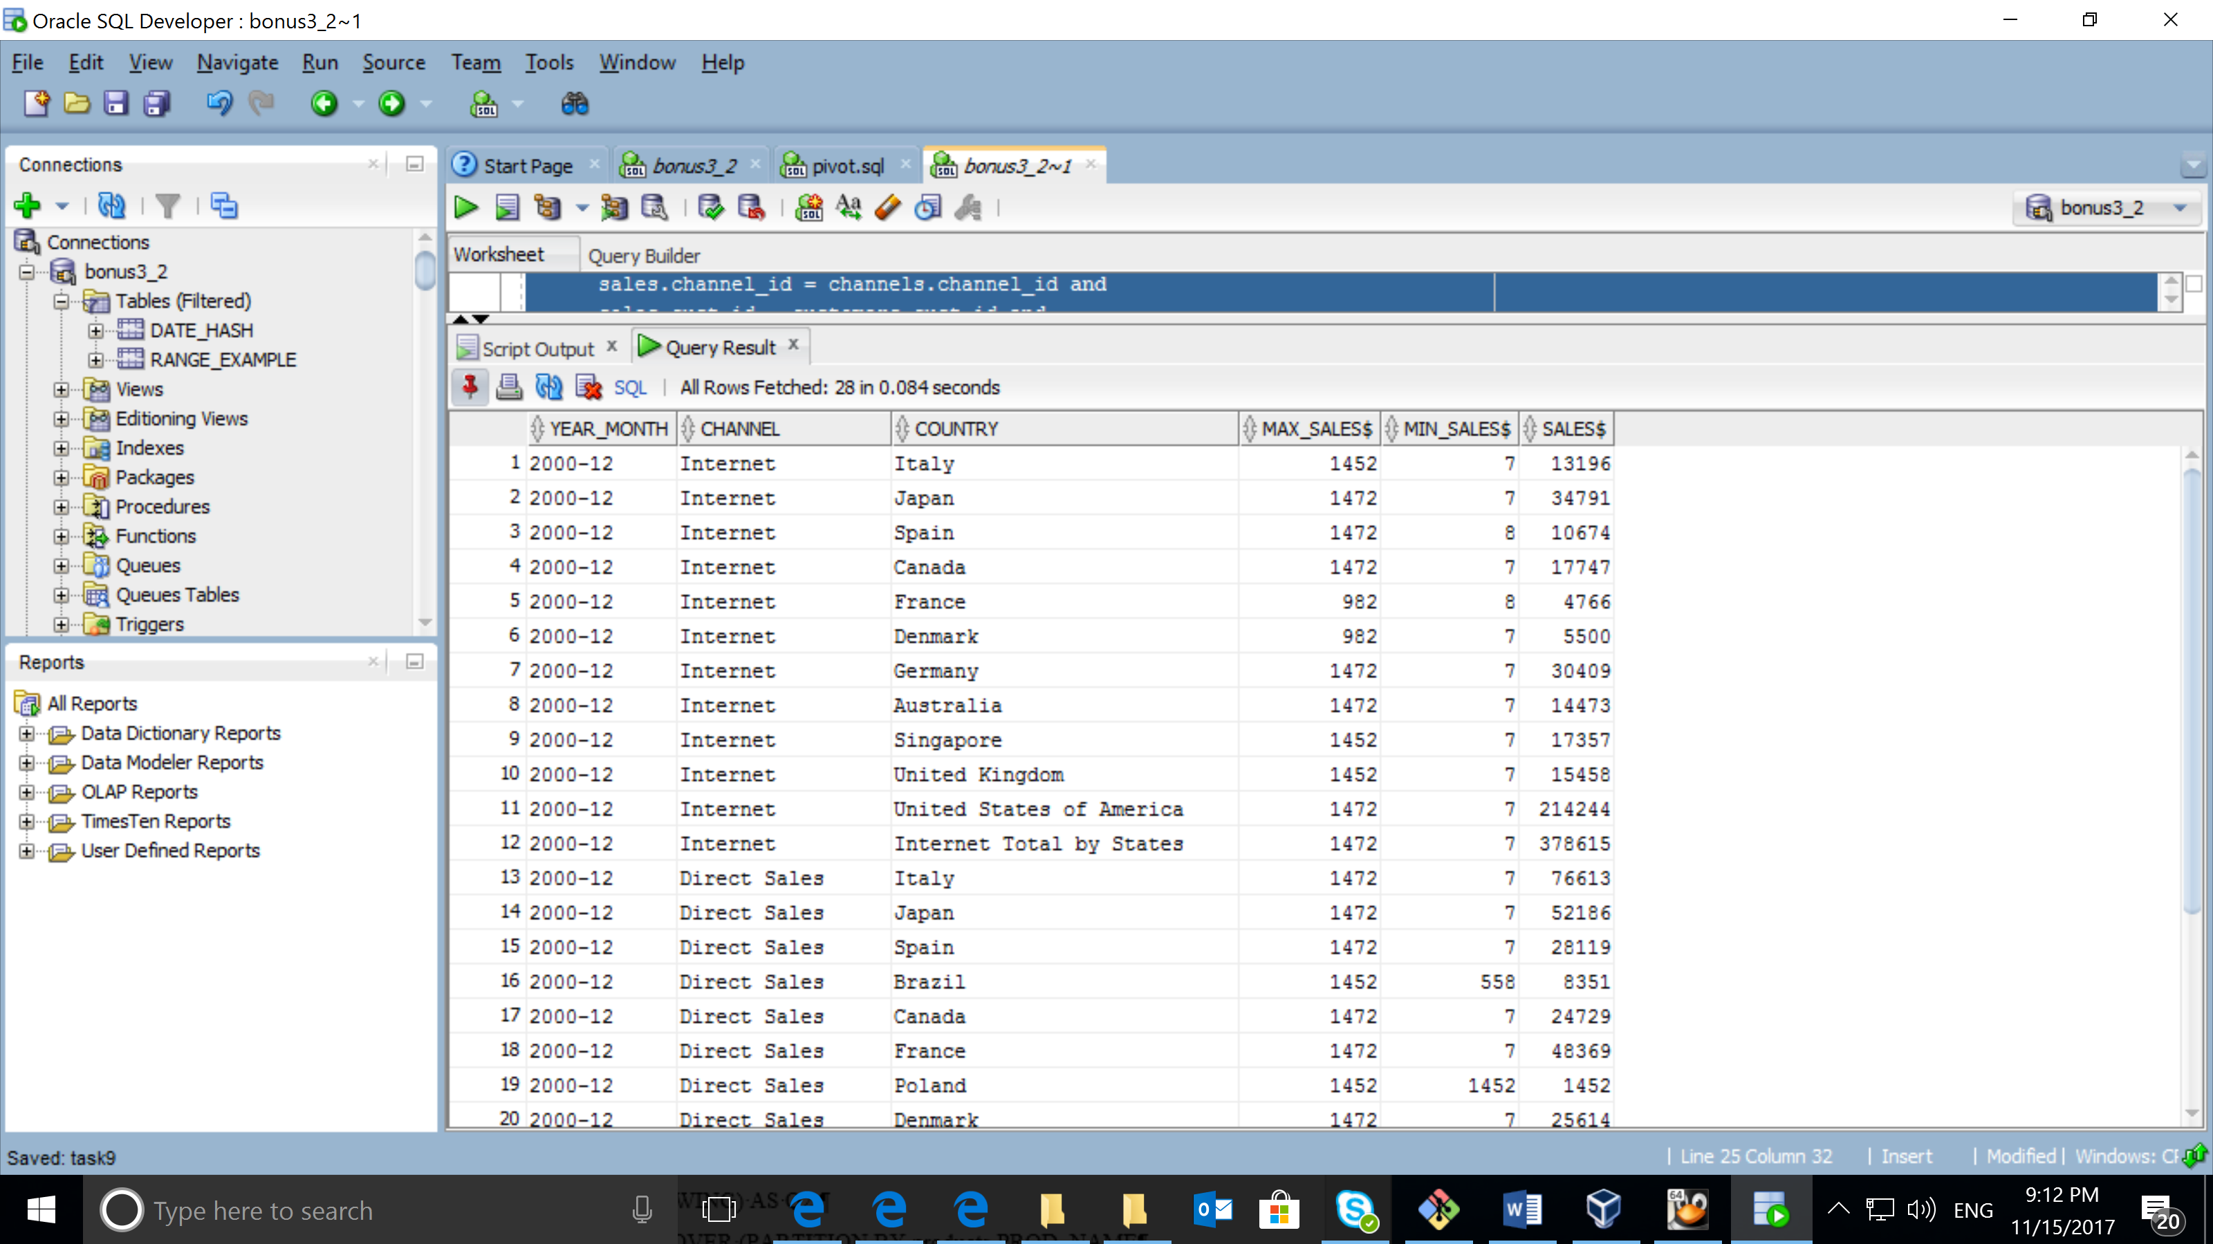

1. Topic 3. Task 2.

CREATE SYNONYM products FOR sh.products;

CREATE SYNONYM times FOR sh.times;

CREATE SYNONYM countries FOR sh.countries;

CREATE SYNONYM customers FOR sh.customers;

CREATE SYNONYM sales FOR sh.sales;

SELECT DISTINCT

NVL(products.prod_name,'TOTAL') prod_name,

NTH_VALUE(SUM(AMOUNT_SOLD),1) OVER (PARTITION BY products.PROD_NAME

ORDER BY times.CALENDAR_QUARTER_NUMBER ASC RANGE BETWEEN UNBOUNDED

PRECEDING AND UNBOUNDED FOLLOWING) AS Q1,

NTH_VALUE(SUM(AMOUNT_SOLD),2) OVER (PARTITION BY PRoducts.PROD_NAME

ORDER BY Times.CALENDAR_QUARTER_NUMBER ASC RANGE BETWEEN UNBOUNDED

PRECEDING AND UNBOUNDED FOLLOWING) AS Q2,

NTH_VALUE(SUM(AMOUNT_SOLD),3) OVER (PARTITION BY products.PROD_NAME

ORDER BY Times.CALENDAR_QUARTER_NUMBER ASC RANGE BETWEEN UNBOUNDED

PRECEDING AND UNBOUNDED FOLLOWING) AS Q3,

NTH_VALUE(SUM(AMOUNT_SOLD),4) OVER (PARTITION BY products.PROD_NAME

ORDER BY Times.CALENDAR_QUARTER_NUMBER ASC RANGE BETWEEN UNBOUNDED

PRECEDING AND UNBOUNDED FOLLOWING) AS Q4,

SUM(SUM(AMOUNT_SOLD)) OVER (PARTITION BY products.PROD_NAME) AS YEAR_SUM

FROM

sales, times, products, customers, countries

WHERE

sales.time_id = times.time_id

AND sales.prod_id = products.prod_id

AND sales.cust_id = customers.cust_id

AND customers.country_id = countries.country_id

AND times.fiscal_year = '2000'

AND countries.country_region = 'Asia'

AND products.prod_category = 'Photo'

GROUP BY ROLLUP(prod_name), times.calendar_quarter_number

ORDER BY prod_name nulls last;

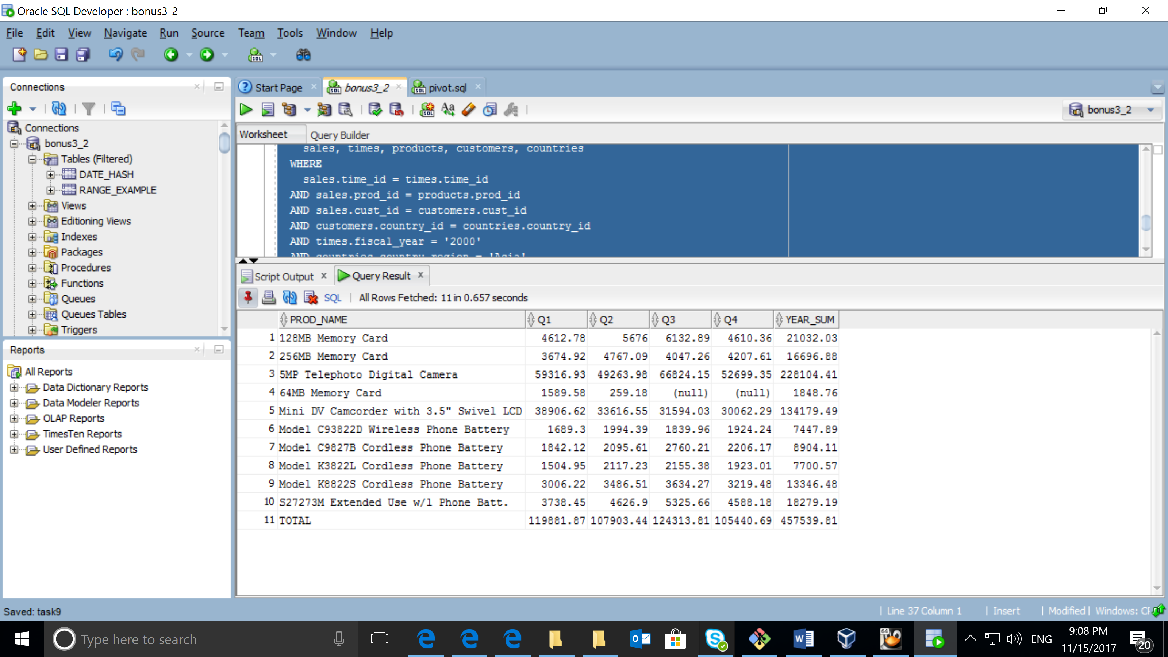

1. Your personal example of PIVOT

create view SALES_VIEW as

select PROD_NAME PRODUCT,

COUNTRY_NAME COUNTRY,

CHANNEL_ID CHANNEL,

SUBSTR(CALENDAR_QUARTER_DESC, 6,2) QUARTER,

SUM(AMOUNT_SOLD) AMOUNT_SOLD,

SUM(QUANTITY_SOLD) QUANTITY_SOLD

from sh.SALES, sh.TIMES, sh.CUSTOMERS, sh.COUNTRIES, sh.PRODUCTS

where sh.SALES.TIME_ID = sh.TIMES.TIME_ID and

sh.SALES.PROD_ID = sh.PRODUCTS.PROD_ID and

sh.SALES.CUST_ID = sh.CUSTOMERS.CUST_ID and

sh.CUSTOMERS.COUNTRY_ID = sh.COUNTRIES.COUNTRY_ID

group by PROD_NAME, COUNTRY_NAME, CHANNEL_ID, SUBSTR(CALENDAR_QUARTER_DESC, 6, 2) ;

